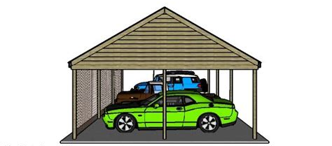
NOTICE OF CARPORT POWER-WASHING

On AUGUST 10, 2022, the Association will be power washing the carports. Please move all vehicles to an open/uncovered parking spot.

Once the covered parking spaces are open, we will attempt to put up caution tape to prohibit any vehicles from parking there until after the project is finished. If any vehicle is still under a carport on August 10^{th,} we will attempt to cover it with a tarp and proceed with the power-washing, however the Association and/or any vendor will not be responsible for any damage to any vehicle.

The project will begin at approximately 8am on August 10th and will continue until complete.

Thank you for your cooperation during this project.

Sincerely,
Oak Creek Board of Directors and Veracity

